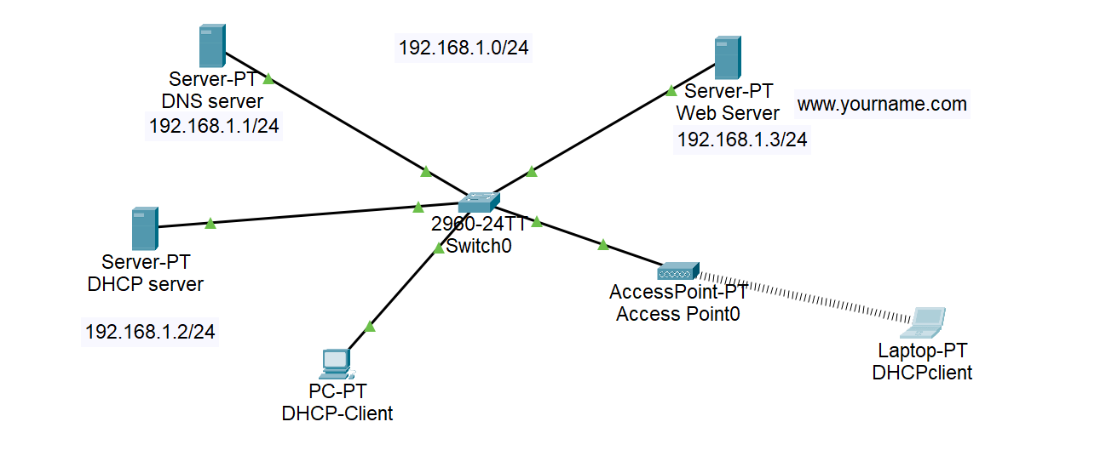Workshop:

1. Create a network with 192.168.1.0/24 network and create a DCHP server, DNS server and web server.
2. Create DHCP server in DHCP server computer and with start IP from 192.168.1.100.
3. Create a access point and Make SSID your name and password collegename123.
4. Assign PC-PT with DHCP address.
5. Make an entry of Web Server(192.168.1.3) as [www.yourname.com](http://www.yourname.com) (please put your name) in DNS server.
6. Goto browser of Laptop and enter [www.yourname.com](http://www.yourname.com) .
7. If it works good but not then troubleshoot.